Name: _______________ Section Time: ______________________

1) – 4) Filling the blanks below using (a) – (d)

(a) substitutional impurity (b) vacancy (c) self interstitial (d) impurity interstitial

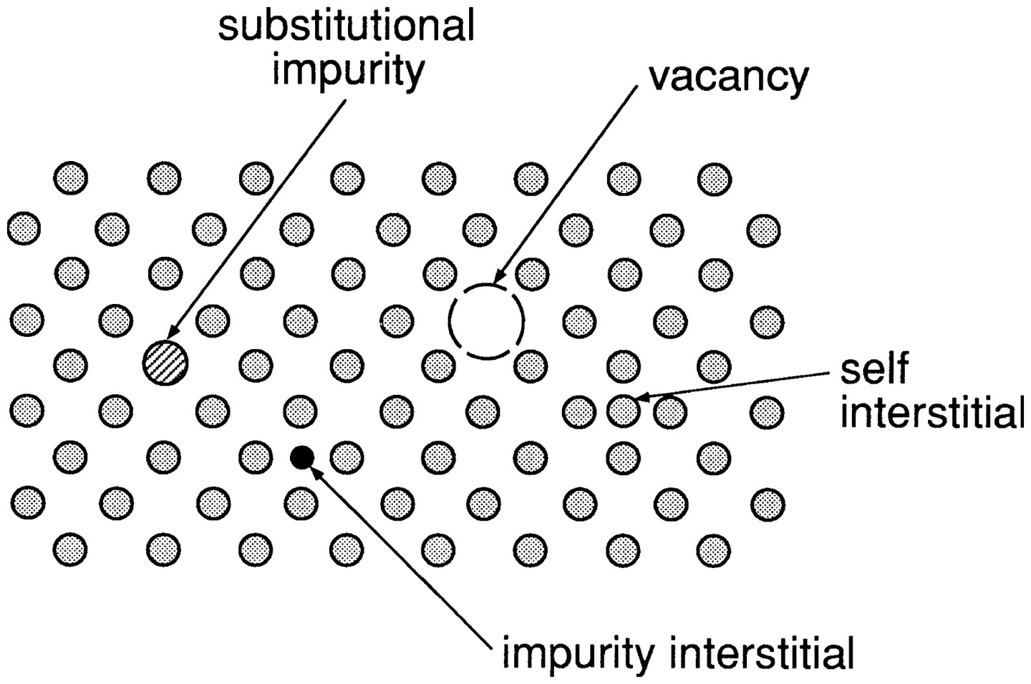

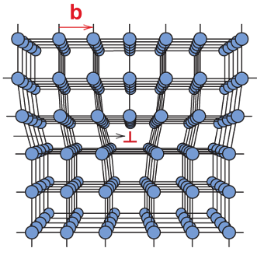
5) The figure below illustrates what imperfection?

(a) a screw dislocation
(b) an edge dislocation
(c) a grain boundary
(d) a gas pore

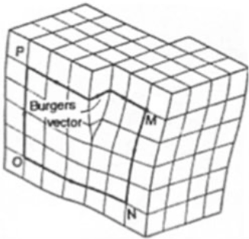
6) The figure below illustrates what imperfection?

(a) a screw dislocation
(b) an edge dislocation
(c) a grain boundary
(d) a gas pore

7) When more than one solid crystal (called grains in metals and ceramics) forms as molten materials solidify, area imperfections are created known as
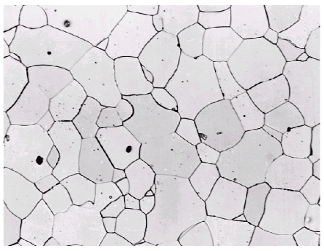
(a) vacancies
(b) dislocations
(c) grain boundaries
(d) gas pores

8) Grain boundaries have the following properties or functions, except:

(a) low density in grain boundaries

(b) are less susceptible to etching

(c) high mobility and high chemical reactivity

(d) change in crystal orientation

9) The following are volume defects, except

(a) gas pores (b) foreign inclusions (c) dislocations (d) cracks

10) Calculate the ASTM Grain Size Number for the following condition: Approximately 4 grains seen in a 1"x1" area at 400X mag.

(a) 3 (b) 5 (c) 7 (d) 10

11) Calculate the ASTM Grain Size Number for the following condition: Approximately 45 grains can be seen in a 1"x1" area at 100X mag.

(a) 4.5 (b) 5.5 (c) 6.5 (d) 7.5

12) The ASTM Grain Size Number is 6.5. Approximately how many grains can be seen in a 1"x1" area at 85X mag.

(a) 30 (b) 44 (c) 63 (d) 75

13) “The grain size of metal sheet influences its formability in two opposing ways. The yield strength of a metal increases as the grain size decreases. So, the formability of a component may decrease if the grain size gets too small. Larger grained metals have better formability, but the roughened surface that results from stretching metal with grain sizes that are too large is unacceptable for many applications. During a recrystallization anneal new grains form in the metal. The final grain size depends on the annealing temperature and annealing time.”

As shown in the figure below (1"x1" area under a 100X magnification microscope), a cold-rolled metal has been annealed at different temperatures for one hour. Calculate the ASTM Grain Size Number for the condition: Annealed at 550ºC.
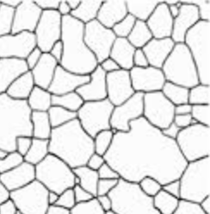
(a) 4 (b) 5 (c) 6 (d) 7

14) For the problem above, calculate the ASTM Grain Size Number for the condition: Annealed at 650ºC.
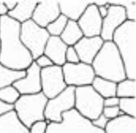
(a) 4 (b) 5 (c) 6 (d) 7

http://www.imetllc.com/tag/grain-size/

